6 Week Shred Email Swipes

Affiliate link: http://XXX.6weekshred.hop.clickbank.net/

**Replace XXX with your Clickbank ID.

Subject Line Options: CrossFitter Tells All + Ripped Ab Pic

With all the slack that CrossFitters get these days, there's no doubt that these guys (and gals) are insanely RIPPED...

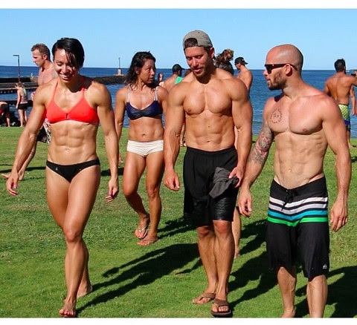
Just take a look at their physiques…
Those are some pretty intense physiques...

Now, I recently met a big name in the Crossfit Industry - Robby Blanchard....

And he reveals a unique bodyweight protocol that will show you how you can achieved that RIPPED physique in less than 45 minutes a week.

It's pretty impressive... check it out on the next page...

=> CrossFitter Reveals a Unique Bodyweight Protocol To Get You Insanely RIPPED In Less Than 6 Weeks <= No Gym Equipment Needed

To your success,
-Sign OFF-
SUBJECT: CrossFit = Ripped Abs?

Say what you want about CrossFit, there's no doubt that these guys (and gals) have awesome abs...

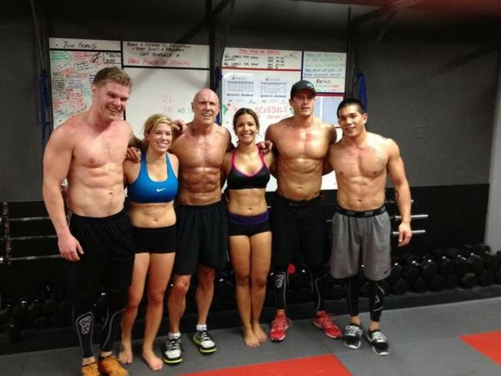
Just check out this pic...
The problem I have with traditional CrossFit workouts is that they are VERY hard on the joints and can cause serious injury.

However, recently I met a big name in the CrossFit industry by the name of Robby Blanchard....

and he showed me his unique CrossFit protocol using just your body weight.

This pretty much eliminates the risk of injury while still giving you the results like you see above...

and in less than 45 minutes a week.

It's pretty impressive... check it out on the next page...

=> CrossFitter Reveals a Unique Body weight Protocol To Get You Insanely RIPPED In Less Than 6 Weeks <= No Gym Equipment Needed

Have a great day,

-Sign Off-

