6 Week Shred Email Swipes

Affiliate link: http://XXX.6weekshred.hop.clickbank.net/

**Replace XXX with your Clickbank ID.

Subject Line Options:

How To Finally Get Shredded Abs

A Secret Formula To Getting A Lean Body And Shredded Abs UNLOCKED

If you’ve watched ESPN or 60 Minutes lately then you’ve probably heard about the latest fitness craze that is getting taking over the fitness world.

It’s one of the fastest growing workouts today and here is the thing….it is not going away.

Why? Because it works and people are getting AMAZING results.

When you look at those people doing those workouts on TV all you can see is every single one of them have SHREDDED Abs and amazing physiques right?

And these men and women that are performing these workouts don’t ever have to worry about having love handles or flabby stomaches and instead these men and women have shredded bodies that are always bathing suit ready.

What’s there secret? I’m going to tell you what their secret method is to having a toned body and shredded abs here:

>>>How To Get Shredded Abs Be “Beach Ready” All Year Long Using This Secret Program

You need to check this out if YOU…

*Have stubborn stomach fat and you’d rather have a flat stomach that will make people jealous

* Want a stronger core and body that will help you virtually eliminate back, knee and shoulder pain.

*Want a body that is always ready for the beach all year round.

*Want to turn your body into a fat FURNACE and eliminate your love handles.

*Experience the same type of results with this secret method that has helped hundreds of thousands of people transform their body.

>>> CLICK HERE: How To Get Shredded Abs Using This Secret Program

Ready for the best part? With this secret method, you don’t even need to own one single piece of equipment. Even better…you can literally transform your body in less than 45 minutes a week.

Learn more about this BRAND NEW state of the art info on how you can get a SHREDDED and lean body in less than 45 minutes a week with this secret method.

========================================================

EMAIL SWIPE #2

Affiliate link: http://XXX.6weekshred.hop.clickbank.net/
*Replace XXX with your clickbank ID.

Subject Line Options:

Are YOU Making These 3 Critical Workout Mistakes?

AVOID These 3 Training Mistakes At All Costs!

When it comes to workouts that will transform your body and give you shredded abs and a lean beach ready body…there are 3 mistakes that you MUST avoid.

If you are making these 3 mistakes (chances are you are making at least one of them) then you are actually doing more HARM than good!

But here is the good news…once you stop making these critical mistakes, you will see your results go through the roof!!

Critical Mistake #1: You Are Doing Too Much!

It sounds crazy…but when it comes to your results and getting your dream body…less is more.

The most common mistake that people make when working out is that they just do too much. Two hour workouts and 500 reps are counter productive and will do more harm than good.

In fact, studies have proven that short burst workouts in the 10-15 minute range are actually more beneficial when it comes to transforming your body and getting shredded abs.

If you are spending more than 10-20 minutes in a workouts..you are doing too much and its time to adjust.

Critical Mistake #2: Isolating Muscle Groups

When it comes to movement and getting a body like an athlete…you cannot isolate muscle groups in your workouts.

What I mean by that is that in order to burn the most amount of calories while building strength and lean muscle…you have to be performing compound functional movements. Running, squatting, jumping, pushing, pulling.

These are common movements performed by athletes that are actually functional movements built into our DNA.

And when we workout using these movements, we are turning on our fat burning receptors and reigniting our bodies to burn fat and build lean muscle.

In addition to that…function movements cut your workout time in half because of how many muscle groups your are working at a time!

Critical Mistake #3: Focusing On Just Your Abs

If all you do is focus on working your abs by doing sit-ups and crunches…I hate to break it to you…but you will never get the body you want.

In order to transform your body…you have to work the body as a whole.

Spot reducing doesn’t work and in order to transform your whole body, including your abs…you need to work the whole body.

Thankfully for you, I’ve got a unique method to train your whole body in just 10-15 minutes that doesn’t rely on high reps…but instead focuses on simple but devastatingly effective movements that will have that unwanted fat melting off of your body.

Think about it…would you rather spend hours doing workouts that you have no idea if they will work or would you rather use a proven method that will get you 2-3x the results in less than 45 minutes a week?

Discover How You Can Reap The Benefits Of This Proven Training Method By Clicking Here.

Sign off

P.S. This method of training is PROVEN to melt off stubborn fat in just 45 minutes a week and will get you the lean body that most of your friends wish they had.

Don’t miss out on this.

>>>Learn How To Turn Your Body Into A Fat Burning Furnace

=========================================================

Email Swipe #3

Affiliate link: http://XXX.6weekshred.hop.clickbank.net/

Replace XXX with your Clickbank ID.

Subject Line Options:

Get Rid Of Belly Fat…By Training Like An Athlete

Train Like An Athlete To Burn Belly Fat

One of the most difficult places to lose weight and fat is in your lower belly.

In fact, the number one questions I get asked by clients is “how do I lose my lower belly fat?”

It’s a huge problem but thankfully there is a solution.

I was talking with my good friend and well known training and strength and conditioning coach Robby Blanchard and from him I learned from him that there is a solution to the huge problem of getting rid of lower belly fat.

Train like an athlete.

Here’s the thing…have you ever seen a professional athlete that doesn’t have an amazing body and flat, shredded stomach? No right?

Well the reason why is all of these athletes don’t train to lose belly fat…they train for performance in their sport or workout.

And because of that…the lack of belly fat on them is the symptom of their workouts.

Pretty cool right? Even better…you can have the same type of results even if you’ve never considered yourself to be an athlete or athletic.

In fact, Robby’s BRAND NEW training program, 6 Week Shred teaches you exactly how you can start to train/think like an athlete with his easy to follow short workouts that will help you lose up to 29 pounds…all while working out less than an hour PER week!

=> Get Robby’s Brand NEW program here

Think about it….

With Robby’s program you won’t have to deal with…

Anymore Lower Belly Fat.

Muffin tops or love handles either.

Instead, you’ll finally have the Shredded, athletic looking body that you’ve dreamed of.

I know you think you’ve heard it all before. However, I promise you never seen anything like this awesome (and crazy effective) program.

Don’t miss out on Robby’s NEW 6 Week Shred training system where you won’t ever have to worry about belly fat again.

=> CLICK HERE – To Learn How You Can Transform Your Body With 6 Week Shred.

Sign Off

=======================================================================

EMAIL SWIPE #4

Affiliate link: http://XXX.6weekshred.hop.clickbank.net/
*Replace XXX with your clickbank ID.

Subject Line Options:

LAST CHANCE To Lose Belly Fat FAST

LAST CHANCE To Get ALL These Bonuses For FREE

For the last few days I’ve been talking to you about World Class Strength and Conditioning and Fitness Trainer Robby Blanchard’s BRAND NEW 6 Week Shred Training program…

I want to let you know that this is your very last chance to get the most ground breaking and next level training program for losing belly fat and turning your body into a fat burning furnace for an INSANE discount..

>>Get Robby’s 6 Week Shred system here.

On top of the INSANE discount opportunity, Robby is also including a couple amazing bonuses that make this opportunity a complete no brainer for you…

AMAZING BONUS #1: Complete How-To Videos

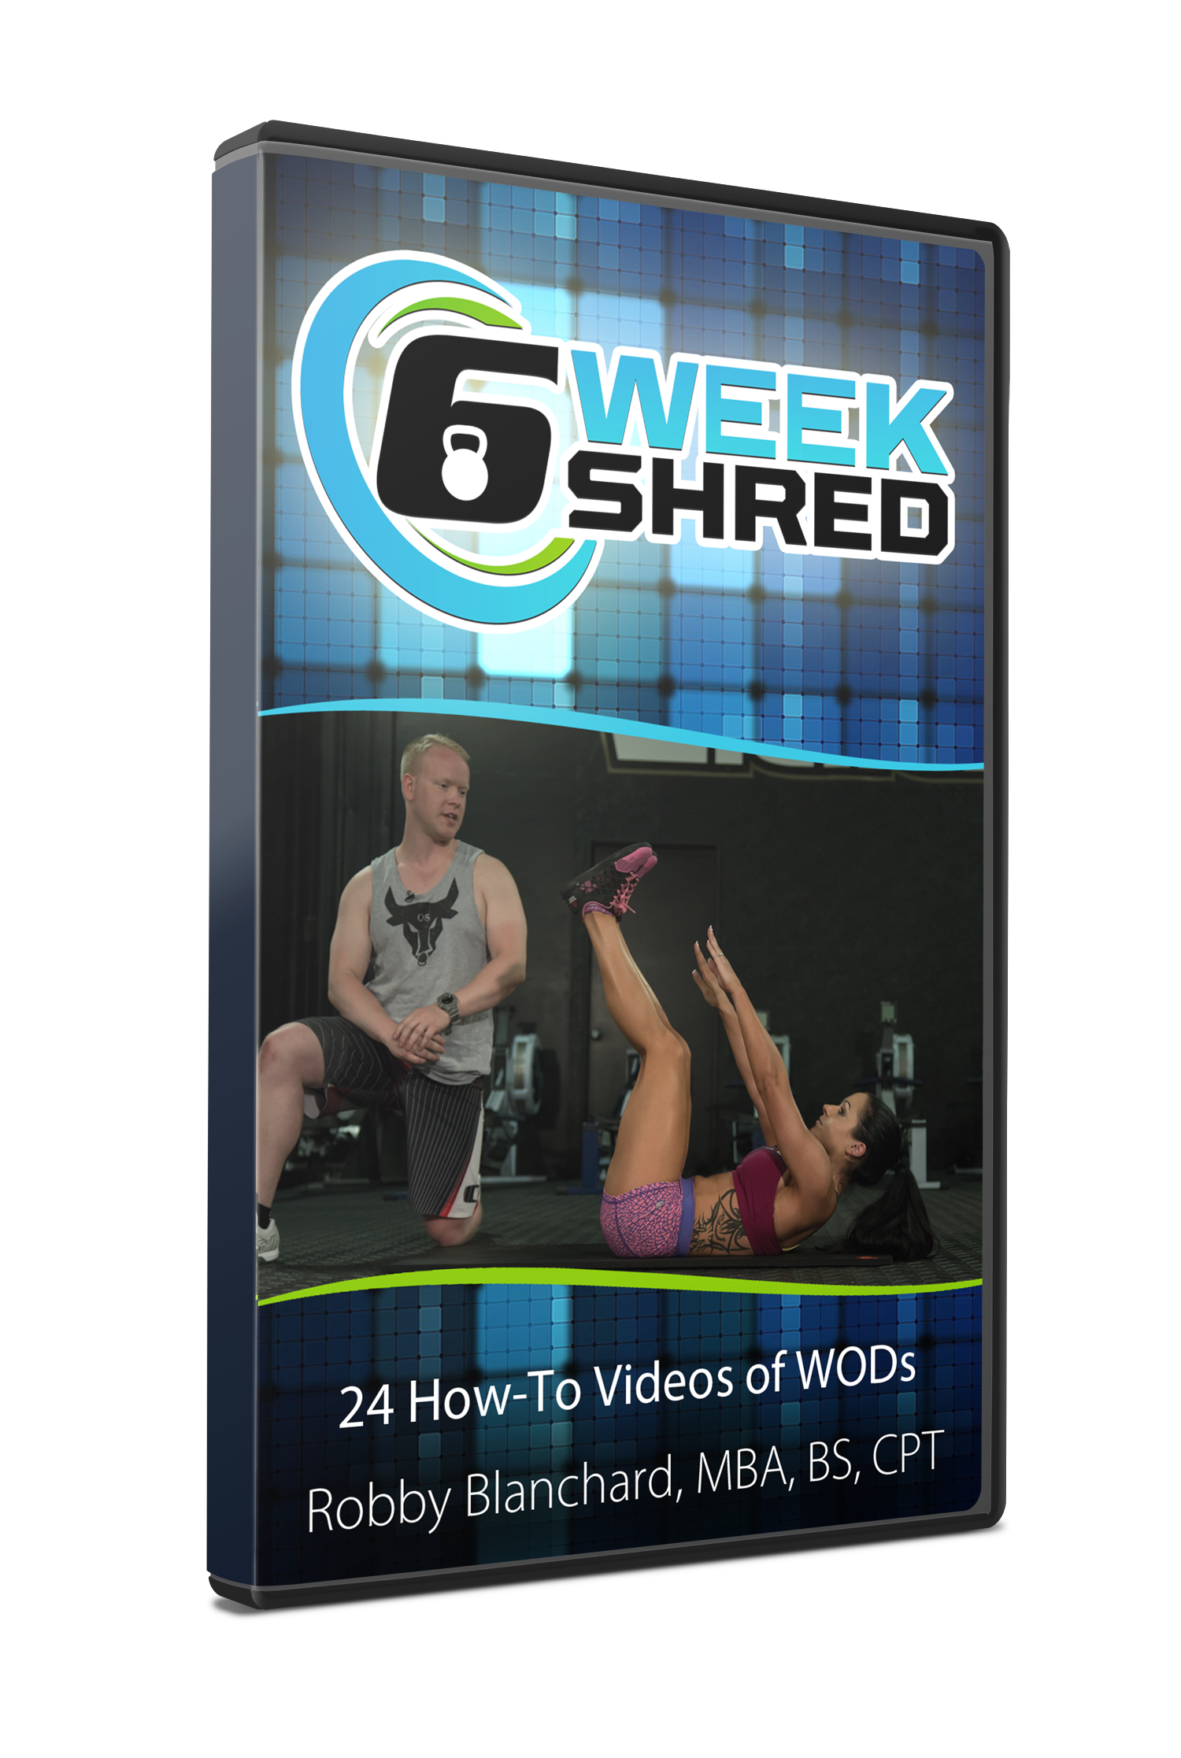
Robby’s gone the extra mile with this training system and has spent thousands on putting together the best how-to videos for each workout in 6 Week Shred. There is literally no guess work with this program and you’ll have Robby coaching you every step of the way to virtually guarantee your success.

AMAZING BONUS #2: 21 Ab Washout Finishers

In addition to the regular workouts you are getting, Robby’s also included his very best Ab workout routines that will not only get your abs SHREDDED…but when you combine them with the other workouts…say goodbye to that stubborn belly fat.

Oh…and Robby’s thrown in the 21 How-To Videos for ALL of the Ab Washout workouts…crazy right?

AMAZING BONUS #3: 2 Additional Weeks of Workouts AND How-To Videos

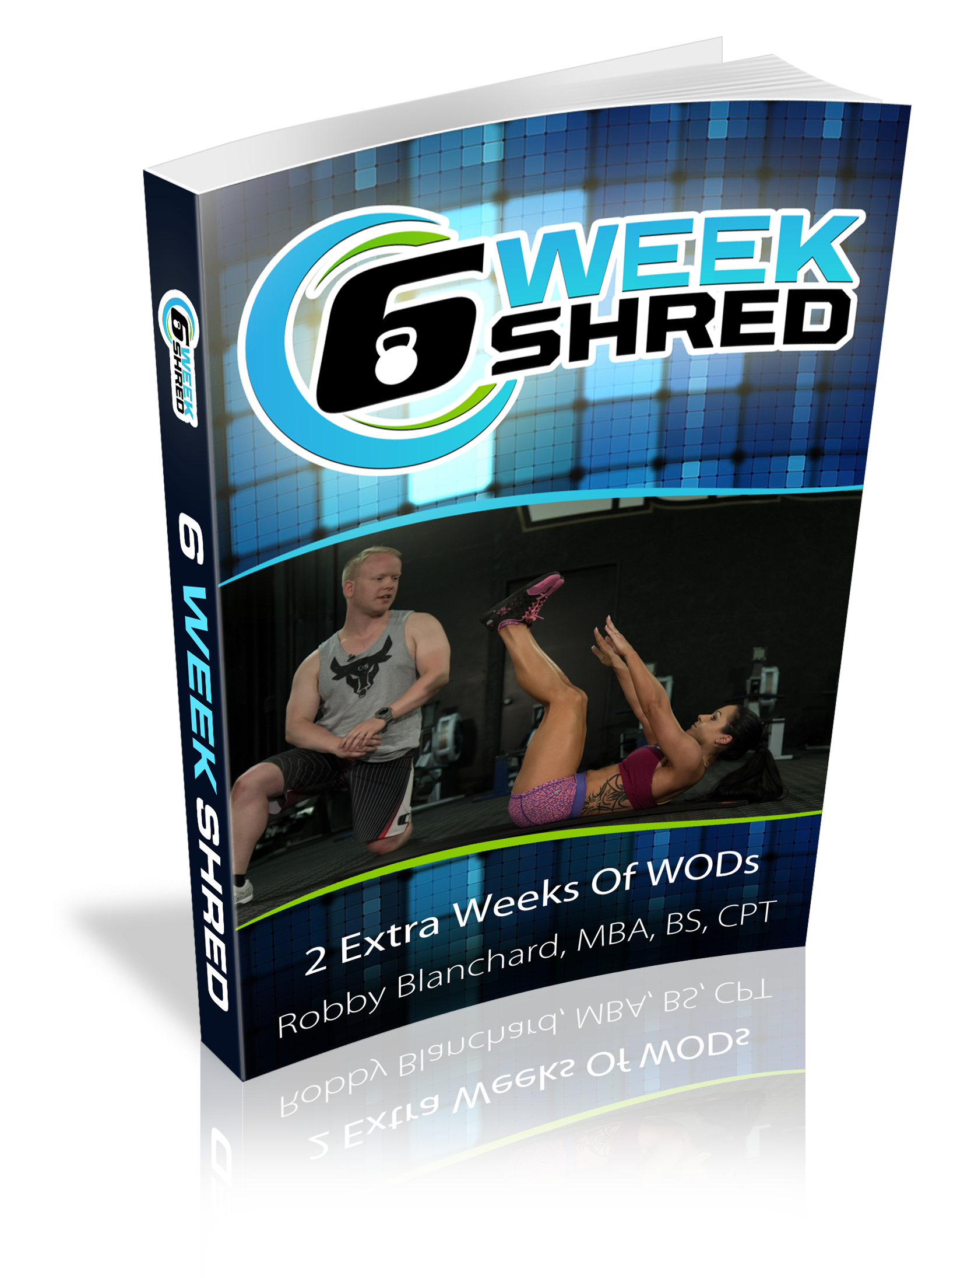
In addition to the full 6 Week Program…Robby is throwing in an addition 2 FULL Weeks of Workouts and how-to videos.

These Bonuses Alone are a $249 value…and Robby is throwing them in for FREE because as he told me…he is so confident in his game changing program that he wants to do everything he can to guarantee your success with his program.

However, you only have about 7 hours left before the price DOUBLES…

LAST CHANCE => Get 6 Week Shred Before Midnight And Claim Your HUGE Discount AND Robby’s Amazing BONUSES <= Ends At Midnight

Trust me when I say this... you won't regret taking me up on this rare opportunity.

I look forward to hearing about your results with this Robby’s Brand NEW game changing 6 Week Shred system.

To your success,

Sign off

